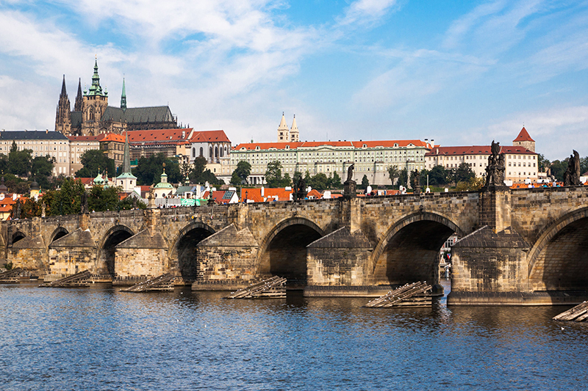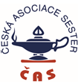

**SEKCE**

**PERIOPERAČNÍCH SESTER**

*Motto: "WE IMPROVE COMPETENCIES AND EXPERIENCES IN PERIOPERATIVE CARE"*

ORGANIZE

**Č A S**

The 7th - 8th of june 2018

Hotel OLŠANKA/PRAGUE

VII. CongreSs

OF PERIOPERATIVE NURSES

WITH INTERNATIONAL PARTICIPATION

AND PATRONAGE ÚVN PRAGUE

**MAIN TOPIC :**

* Changes in Czech legislation and competences of perioperative nurse
* Infection control in surgery
* EN 13 795 - surgical draping
* Varies – comprehensive perioperative nursing care in surgery

**ACTIVE PARTICIPATION**

ORAL PRESENTATIONS/POSTERS **Submit till 15th of February 2018.**

Deadline abstract submission in electronic form **15th April 2018.**

Final program will be published The**31st March 2018.**

**REGISTRATION: http://www.cnna.cz/**

**CONTACT: Ing. Bc. Zuzana Holečková/E-MAIL: zuzana.holeckova@uvn.cz**

PARTICIPATION FEES

|  |  |  |  |
| --- | --- | --- | --- |
| PASSIVE PARTICIPATION | | | |
| **7th – 8th JUNE 2018 lunch first day, coffee break, certificate, social program (payment to 15th of May)** | **800,- Kč/**  **31,- Eu** |
| **One day registration - 7th June 2018 lunch , coffee break, certificate (payment to 15th of May)** | **400,- Kč/**  **16,- Eu** |
| **One day registration - 8th June 2018 lunch , coffee break, certificate (payment to 15th of May)** | **300,- Kč/**  **12,- Eu** |
| **Social program 7th June 2018 (payment to 15th of May)** | **400,- Kč/**  **16,- Eu** |
| **ČAS member (payment to 15th of May)** | **300,- Kč/**  **12,- Eu** |
| **On site registration payment** | **1 000,- Kč/**  **40,- Eu** |
| **ČAS member one day** | **150,- Kč** |
| ACTIVE PARTICIPATION | | | |
| **First author** | **0,- Kč** |
| **Second author** | **300,- Kč/**  **12,- Eu** |

**Payment by bank transfer 115-1561450217/0100**

**Variable symbol date of the congress in form: 07062018 7. 6. 2018**

**Specific symbol date of the birth in the form: 01121955 1. 12. 1955**

**Enter the name and surname in the note.**

ACCOMODATIONS

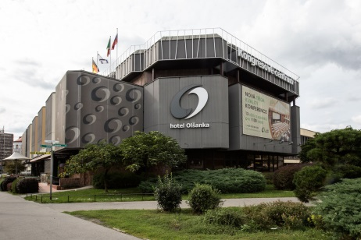**Hotel Olšanka Prague. Book at: rezervace@hotelolsanka.cz. The password in the note: „*ČAS*“.**

**Contact: https://www.hotelolsanka.cz**

**E-mail:** **rezervace@hotelolsanka.cz**

**Phone: +420 267 092 202**

**Adress: Hotel Olšanka s.r.o., Praha 3, Táboritská 23/1000, PSČ 130000**

**NEAR ACCOMADATION– HOTEL ARISTON, HOTEL VÍTKOV NA OHRADĚ.**

Congress technology

**PC, data projector**

Programm Congress

Thursday 7. 6. 2018

**8.00 – 9.30 REGISTRACION**

**9.30 – 10.00 OPENING CONGRESS**

* **10.00 – 11.00 I. BLOCK: CHANGES OF CZECH LEGISLATION AND COMPETENCES OF PERIOPERATIV NURSE**

**11.00 – 11.30** **COFFEE BREAK**

* **11.30 – 12.45 II. BLOCK: EN 13 795 - SURGICAL DRAPING**

**12.45 – 13.45 LUNCH BREAK**

* **13.45 – 15.00 III. BLOCK: VARIES – COMPREHENSIVE PERIOPERATIVE NURSING CARE IN SURGERY**

**15.00 – 15.30 COFFEE BREAK**

**15.30 – 17.00 IV. BLOCK: INTERACTIVE PERIOPERATIVE CARE**

**17.00 – 18.30 V. BLOCK: INVITATION TO SOCIAL ACTIVITIES**

**19.30 – 24.00 SOCIAL EVENING**

Friday 8. 6. 2018

* **8.30 – 9.30 VI. BLOCK INFECTION CONTROL IN SURGERY**

**9.30 – 10.00 COFFEE BREAK**

**10.00 - 11. VII. BLOCK: VARIES – COMPREHENSIVE PERIOPERATIVE NURSING CARE IN SURGERY**

**11.15 – 11.45 COFFEE BREAK**

**11.45 – 13.00 VIII. BLOCK: SPECIFIC PERIOPERATIVE CARE**

**13.00 – 13.15 CELEBRATION OF THE CONGRESS**

Poster

Partners congress